Integrate custom tools into your agent
- Introduction:
  - The AI Agent Service provides built-in tools for gathering knowledge and generating code, which provide your agent with some powerful functionality. However, sometimes your agent needs to be able to complete specific tasks or actions that an AI model would struggle to handle on its own. To accomplish these actions, you can provide your agent a custom tool based on your own code or a third-party service or API.
- Why use custom tools:
  - Common scenarios for custom tools in agents
    - Scenario: A retail company integrates a custom tool that connects the Azure AI Agent to their customer relationship management (CRM) system.
    - Scenario: A manufacturing company develops a custom tool to link the AI agent with its inventory management system.
    - Scenario: A healthcare provider integrates a custom scheduling tool with the AI agent.
- Options for implementing custom tools:
  - Foundry Agent Service provides several custom tool options, including OpenAPI-specified tools, Azure Functions, Azure Logic Apps, and function calling. These tools enable seamless integration with external APIs, event-driven applications, and custom functions.
- How to integrate custom tools:
  - Start by defining a function that the agent can call. For instance, here's a fake snowfall tracking function:
  - 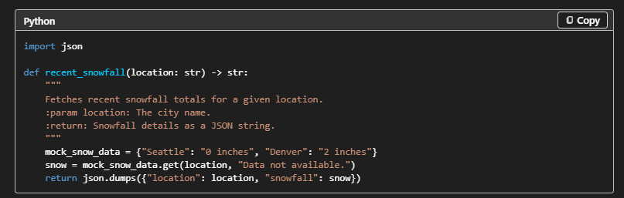
  - Register the function with your agent using the Azure AI SDK:
  - 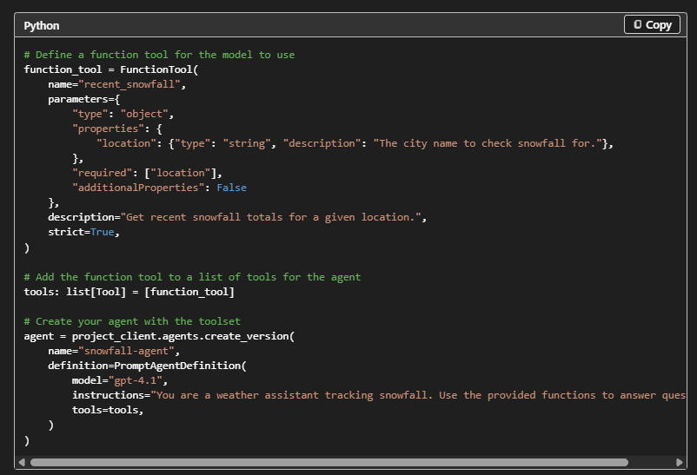
  - Azure Functions provide serverless computing capabilities for real-time processing. This integration is ideal for event-driven workflows, enabling agents to respond to triggers such as HTTP requests or queue messages.
  - Using Azure Functions with a queue trigger: When your Azure Function is in place, integrate add it to the agent definition as an Azure Function tool:
  - 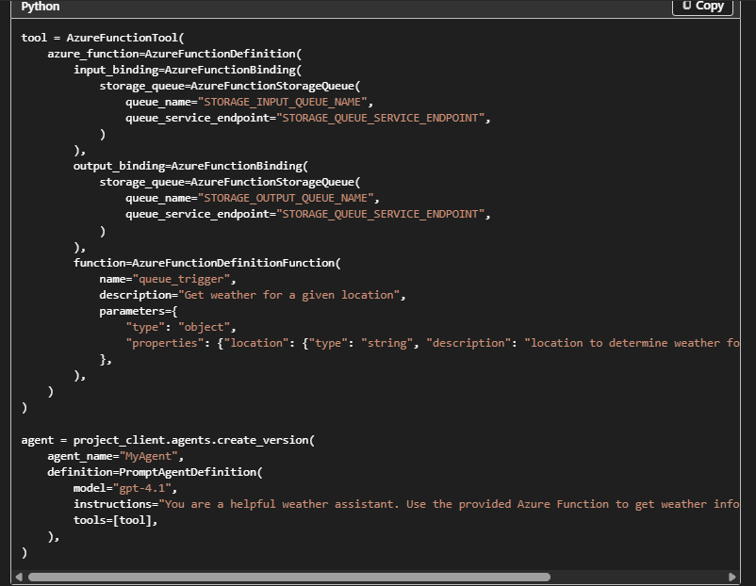
  - OpenAPI Specification: OpenAPI defined tools allow agents to interact with external APIs using standardized specifications. This approach simplifies API integration and ensures compatibility with various services. The Foundry Agent Service uses OpenAPI 3.0 specified tools.
- Exercise: Use a custom function in an AI agent: https://microsoftlearning.github.io/mslearn-ai-agents/Instructions/Exercises/02-agent-custom-tools.html
- Model Assesment:
  - 